Ex.No.4: OFDMA Resource Block Allocation Date
Objective:
1. To determine the Number of Resource Blocks (RBs) allocated in an OFDMA system based on available bandwidth and system configuration.
Objective 1 Matlab Code:
clc; clear; close all;
% System parameters
bandwidth = 10e6; % 10 MHz
rb_size = 180e3; % 180 kHz per RB
% Total Resource Blocks
total_RB = floor(bandwidth / rb_size);
% Users
users = 1:6;
% RB allocation (simple equal + remainder distribution)
base = floor(total_RB / length(users));
alloc = base * ones(1,length(users));
alloc(1:mod(total_RB,length(users))) = alloc(1:mod(total_RB,length(users))) + 1;
utilization = (alloc / total_RB) * 100;
disp('Total Resource Blocks:')
disp(total_RB)
disp('RB Allocation per User:')
disp(alloc)
figure
% -------- Graph 1: RB Allocation per User --------
subplot(2,1,1)
stem(users, alloc, 'filled', 'LineWidth', 2)
title('OFDMA Resource Block Allocation per User')
xlabel('User Index')
ylabel('Number of Resource Blocks')
grid on
% -------- Graph 2: RB Utilization --------
subplot(2,1,2)
plot(users, utilization, '-o', 'LineWidth', 2)
title('OFDMA Resource Block Utilization (%)')
xlabel('User Index')
ylabel('Utilization (%)')
grid
OUTPUT: on 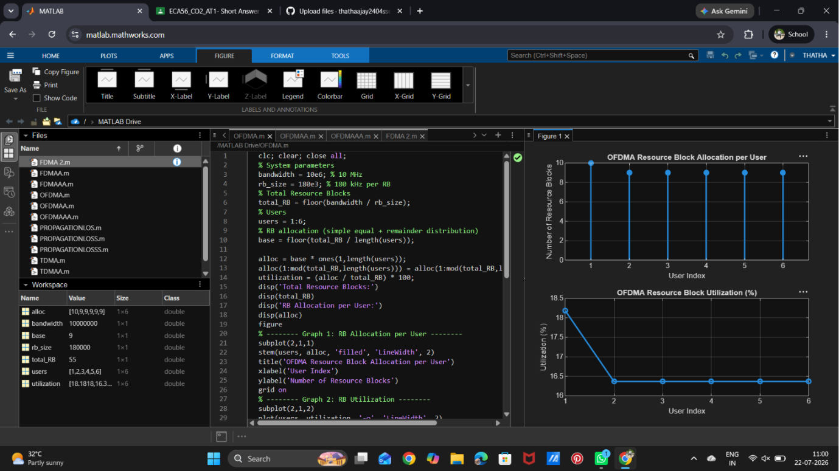

Objective:
2.To evaluate the Resource Block Utilization (%) by analysing how efficiently available RBs are assigned to active users.
Objective 2 Matlab Code:
clc; clear; close all;
% Total system resource blocks
total_RB = 50;
% Number of active users
users = 1:5;
% RB allocation to users (example scenario)
alloc = [12 10 9 8 11];
% Resource Block Utilization (%)
util = (alloc / total_RB) * 100;
disp('Resource Block Utilization (%) per User:')
disp(util')
figure
% -------- Graph 1: RB Allocation --------
subplot(2,1,1)
plot(users, alloc, '-o', 'LineWidth', 2)
title('OFDMA Resource Block Allocation per User')
xlabel('User Index')
ylabel('Number of Resource Blocks')
grid on
% -------- Graph 2: Utilization (%) --------
subplot(2,1,2)
plot(users, util, '-s', 'LineWidth', 2)
title('OFDMA Resource Block Utilization (%)')
xlabel('User Index')
ylabel('Utilization (%)')
grid on
OUTPUT:
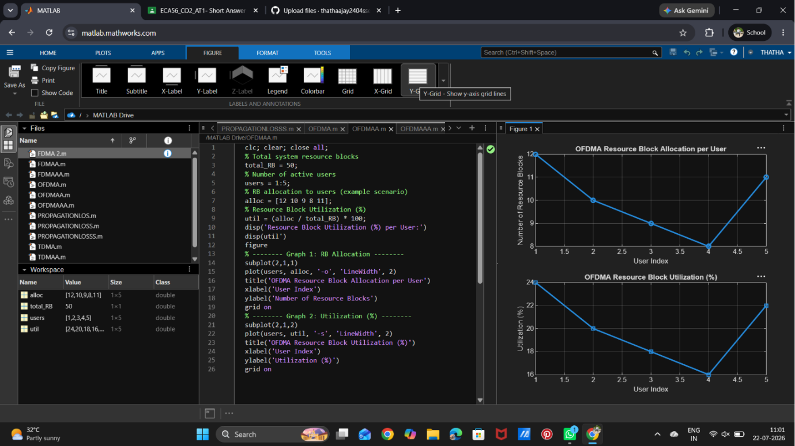
Objective:
3.To calculate the User Throughput (Mbps) based on allocated resource blocks and modulation efficiency in the OFDMA system.
Objective 3 Matlab Code:
clc; clear; close all;
% System parameters
rb_bw = 180e3; % Bandwidth per RB (180 kHz)
users = 1:5;
% Allocated Resource Blocks per user
alloc_RB = [12 10 9 8 11];
% Modulation efficiency (bits/symbol)
mod_eff = [2 4 6 4 2]; % QPSK, 16QAM, 64QAM etc.
% Throughput calculation (Mbps)
throughput = (alloc_RB .* rb_bw .* mod_eff) / 1e6;
disp('User Throughput (Mbps):')
disp(throughput')
figure
% -------- Graph 1: Throughput per User --------
subplot(2,1,1)

plot(users, throughput, '-o', 'LineWidth', 2)
title('OFDMA User Throughput')
xlabel('User Index')
ylabel('Throughput (Mbps)')
grid on
% -------- Graph 2: RB vs Throughput --------
subplot(2,1,2)
plot(alloc_RB, throughput, '-s', 'LineWidth', 2)
title('Resource Blocks vs Throughput Relationship')
xlabel('Allocated Resource Blocks')
ylabel('Throughput (Mbps)')
grid on

OUTPUT:
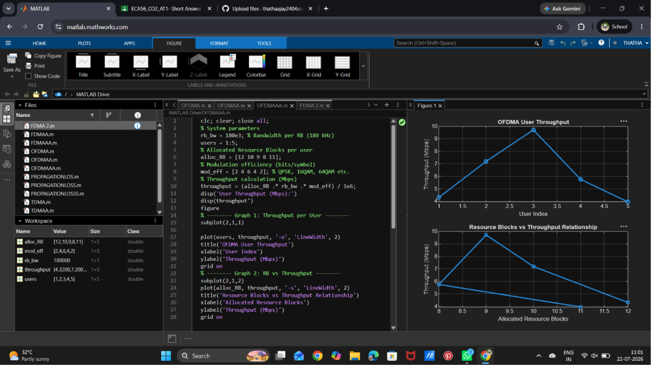

Result:
1. The Resource Block (RB) allocation was successfully simulated for multiple users in the OFDMA system, demonstrating how available spectrum is distributed among active users.
2. The Resource Block Utilization (%) analysis showed efficient usage of system resources, indicating how effectively the available RBs are assigned to users.
3. The User Throughput (Mbps) was successfully calculated based on RB allocation and modulation efficiency, showing that higher allocated RBs and higher modulation schemes result in increased throughput.

